Community Insights: Analysing and Interpreting Your Research Data with AI
A Nature Masterclasses webinar

- How can AI help me design or automate the data collection process?
- How can I critically assess the outputs of AI-generated code?
- How can I protect sensitive or unpublished data when using AI?


CC/peopleimages.com

Artificial intelligence can support researchers at many stages of experimentation, from collecting data to developing models, recognising patterns and troubleshooting problems. Used well, it can save time and open up new ways of working. However, reliable analysis still depends on sound research design, well-managed data and a clear analytical plan. AI cannot compensate for fundamental flaws in a study or turn poor-quality data into reliable evidence.

The challenge for researchers is knowing where AI adds genuine value and how to use it responsibly. How can they verify its outputs and manage risks such as bias, data privacy and security, and conclusions that go beyond the evidence?

In this webinar, you’ll learn from distinguished panellists with expertise in AI research, editorial practice and policy. They will examine the role of AI across data preparation, analyses, interpretation and visualisation. They will offer practical guidance and explain where human judgement and subject expertise remain essential. Whether you are new to AI or already using it in your work, the webinar will help you make more informed decisions about its role in your research.

You will have the opportunity to submit your own questions when you register. Please keep them relevant to analysing and interpreting research data with assistance from AI. Covered topics will help you to:

- Understand how AI can support different stages of data analysis, from planning and preparation to coding, troubleshooting and interpreting scientific results.
- Evaluate where AI adds value while recognising when subject expertise, robust research methods and human oversight remain essential.
- Manage research data responsibly by validating AI outputs, protecting sensitive information, documenting AI use and following institutional, funder and publisher guidance.
- Apply AI in ways to strengthen, rather than replace, your own analytical thinking and research expertise.

Session timings

Time | Registration link
Tuesday 15 September, 17:00–18:00 (BST) | here
Thursday 17 September, 08:00–09:00 (BST) | here
Thursday 17 September, 14:00–15:00 (BST) | here

Experts by session
Americas: Tuesday 15 September, 17:00–18:00 (BST)

 | Ellie Gendle  Head of Journals Policy – Research Integrity, Springer Nature  Ellie joined Springer Nature in 2023 as Head of Performance in the Research Integrity Group, before becoming Head of Journals Policy the following year. She leads the strategic direction of journal editorial policies, overseeing their development, implementation and ongoing compliance. Her work includes shaping Springer Nature policies in response to emerging challenges in scholarly publishing, including responsible use of AI in research and writing.
 | Alexia-Ileana Zaromytidou  Chief Editor, Nature Cancer  Alexia-Ileana completed her PhD at the London Research Institute, Cancer Research UK (now the Francis Crick Institute), followed by postdoctoral research in the lab of Joan Massagué at Memorial Sloan Kettering Cancer Center in New York. In 2019, she became the launch Chief Editor of Nature Cancer, where she handles a broad range of manuscripts, including those involving current AI technologies, and brings insight into how emerging methods are applied and evaluated in high-impact publishing.
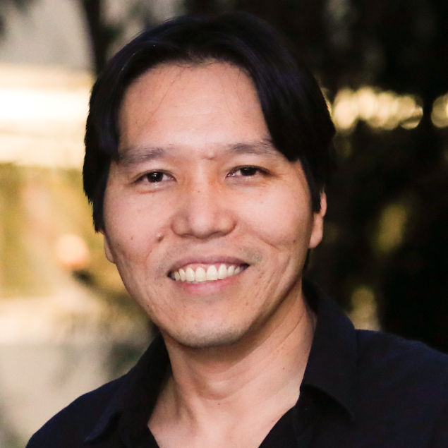 | Helder Nakaya  Associate Professor, Universidade de São Paulo;  Senior Researcher Hospital Israelita Albert Einstein  Alongside his roles at the University of São Paulo and Hospital Israelita Albert Einstein in Brazil, Helder performs additional teaching roles at Emory University and the University of Oxford. His research focuses on systems immunology, using large-scale biological data, network analysis and machine learning to understand immune responses, particularly in infectious diseases and vaccination, including work on predicting vaccine-induced immunity for diseases such as yellow fever.
 | Veda Storey  Tull Professor of Computer Information Systems and Computer Science, Georgia State University  Veda’s research interests are in data management, modelling and design science research. She is particularly interested in the assessment of the impact of new and emerging technologies, including AI systems, on business and society. She plays an active role in editorial leadership and mentoring early-career researchers.

APAC: Thursday 17 September, 08:00–09:00 (BST)

Ellie Gendle
Head of Journals Policy – Research Integrity, Springer Nature

Ellie joined Springer Nature in 2023 as Head of Performance in the Research Integrity Group, before becoming Head of Journals Policy the following year. She leads the strategic direction of journal editorial policies, overseeing their development, implementation and ongoing compliance. Her work includes shaping Springer Nature policies in response to emerging challenges in scholarly publishing, including responsible use of AI in research and writing.
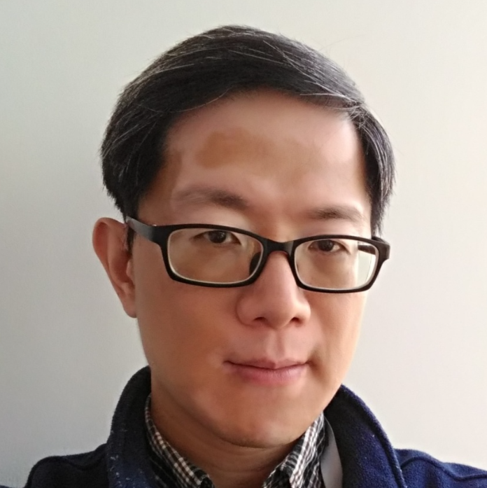 | Ching-yu Huang  Chief Editor for Immunology, Nature Communications  Ching-yu joined the journal in 2016 and handles submissions across immunology, immune cell biology and systems immunology. Prior to this, he was a principal investigator working in immunogenetics, T cell biology and immune signalling. In his editorial role, he handles a broad range of manuscripts, giving him a perspective on how these tools are shaping research practice and publication.
 | Tony Hu  Zhao-Yi Endowed Professor and Founding Dean, School of Biomedical Engineering, Tsinghua University  Tony’s work combines nanotechnology, multi-omics and data-driven methods, including AI use, to advance biomarker discovery and diagnostic development. He focuses on applying computational and engineering approaches to improve how diseases are detected and understood, with emphasis on translating these methods into practical diagnostic tools. In 2025, he received the ADLM Award for Outstanding Contributions to Diagnostics and Laboratory Medicine.
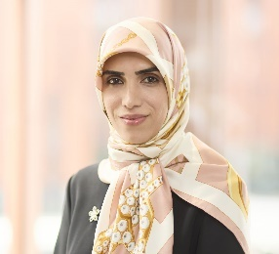 | Fatemeh Vafaee​  Professor, University of New South Wales  Fatemeh is a Professor at the University of New South Wales (UNSW), where she founded the Biomedical AI Laboratory and serves as Deputy Director (Science) of the UNSW AI Institute. A leader in AI-enabled biomedical innovation, she translates advanced artificial intelligence into deployable solutions across drug discovery, precision medicine and AI diagnostics. She is recognised internationally as one of the Top 10 Women in AI in APAC by AI Magazine (2024), and winner of the WAI-APAC Award in Health (2023).

EMEA: Thursday 17 September, 14:00–15:00 (BST)

Ellie Gendle
Head of Journals Policy – Research Integrity, Springer Nature

Ellie joined Springer Nature in 2023 as Head of Performance in the Research Integrity Group, before becoming Head of Journals Policy the following year. She leads the strategic direction of journal editorial policies, overseeing their development, implementation and ongoing compliance. Her work includes shaping Springer Nature policies in response to emerging challenges in scholarly publishing, including responsible use of AI in research and writing.
 | Oliver Graydon  Chief Editor, Nature Photonics  Oliver joined the Nature Publishing Group (now Springer Nature) in 2006 to launch the journal. He has a PhD in optical communications from the University of Southampton’s Optoelectronics Research Centre. He is also a Fellow of Optica. In his editorial role, he oversees the editorial operations at Nature Photonics and pays close attention to how AI-based tools are being applied and evaluated in high-impact publishing.
 | Samraat Pawar​  Professor of Theoretical Ecology, Imperial College London  Samraat's research explores ecological and evolutionary dynamics using mathematical modelling and analyses of large datasets. This includes computational approaches to understanding biological systems. As part of Imperial’s quantitative ecology and AI research community, Samraat is also actively involved in training researchers in data-driven modelling in ecology and evolution.
 | Nicki Tiffin  Professor, University of the Western Cape;  Deputy Director, South African National Bioinformatics Institute  Nicki's research integrates genomics, epidemiological and routine health data using bioinformatics to better understand disease in African populations. She also works on ethics and data governance, developing tools to support responsible research. Nicki applies AI to harmonise and analyse large health datasets, as well as in day-to-day research and administrative tasks. She is a Calestous Juma Science Leadership Fellow with the Bill & Melinda Gates Foundation.

